what reading-feeling do i want to evoke:

LOL - that's so funny
WTF - that pisses me off or this is annoying and rude!
AWW - OMG! i want that for me (or a friend) too or OMG! This gives me goosebumps
WOW - how did you think of this or i never thought of if that way or that's amazing
OHHHH! - now i get it!
FINALLY! - thank goodness, someone finally says it or someone said what i feel
YAY! - that's great news or this is super exciting, I can't wait!

---------------------------------------------------------------------------------------------------------------------------

Selected feeling: WOW - i never thought of if that way

————————————————————---------------------------------------------------------------

Headline:

3 Ingredients to Make your Emails too Delicious to Avoid (harsh truth ahead: your readers sent me to you)

BODY:

If you’re reading this, you’ve probably subscribed to a lot of newsletters you hardly read, lots of them pollute your eyes and make you purge.

I promise if you read till the end your readers would open your emails more.

Do you ever find yourself scrolling through twitter, clicking on a user profile you like, you view their bio, and you see a link to their newsletter opt-in page. You click on it and put in your email.

You get their copy and paste automated “Welcome to my newsletter. I’m so happy blah blah blah……..” welcome email.

You receive the first issue of their shit some days later--then you begin to question why you ever signed up. Since you don’t want to be seen as a SCUM you leave the emails unread till you have more activity in your emails than your bank account:

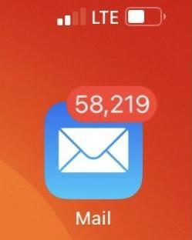

instead of just hitting the “unsubscribe” link at the bottom of the emails.

This happens to the best of us. But today is a great day to unsubscribe from newsletters that don’t serve you anymore and would rather watch you starve to death (Even if it’s your best friend’s newsletters). They don’t have your best interest. Let them GO!

The next time you purge it’s probably the words you’ve read recently. Guard your information diet jealously as you do with your romantic partners.

Here are a couple of things to avoid getting your emails skipped like a rope:

- never use capitals

There’s no written in the stars commandement on why your headline or subheadline needs to be capital. Laura Belgray, the founder of Talking Shrimp uses small letters a lot in her email “headlines” which generates over $1m yearly.

And they work!

I also use it HERE and my readers smile uncontrollably!

Using capitals scream “NEWSLETTER HERE” to the reader and we don’t want that, do we?

As much as we want to hack attention, the words that make up the headline are what matters not capitals.

- cut out the “Y’all”

Whenever you open some emails and see “Y'all” -- isn’t it an immediate turn off? No regard for you. “Y’all” really?

Rude, unforgivable, and an uncultured swine!

You immediately know this person isn’t for you and doesn’t even see you--so why keep hanging out around them.

Better to go somewhere else like hiking or sky diving where you’ll be appreciated, yeah?

Resist the urge to use “Y’all”, except it’s a group hangout.

- no, it’s not a “Newsletter”

The “News” in the “Newsletters” scares us already. We don’t want more “News” in our inbox. So what can you do instead? You gotta find a new language for your stuff.

Letters? Snippets? Whispers? Case studies? Journal? Digest? Snackables? Munchables?

Email list? Hell No!

-------

Before I get back to writing non-newsletter stuff to my ‘letter’ readers, here’s ONE thing your newsletter description should never have. A bunch of copy-pasted lines like:

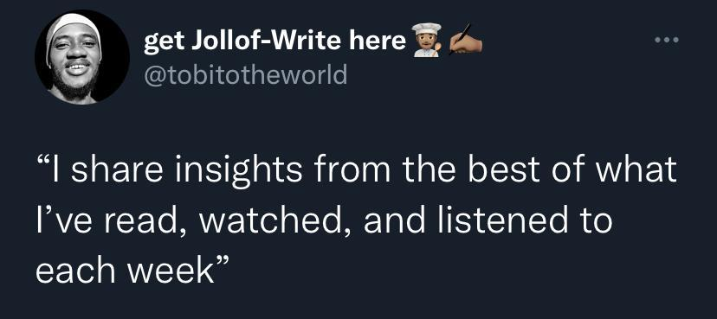

I see lots of newsletter landing pages with this description & it makes me wonder if they think they’re famous enough for people to care about what they read, watch, or listen to every week?

But really, No one cares about what you read weekly and want to shove down our throat--except you’re a Tim Ferris or an Elon Musk.

And my guess is you’re almost unknown.

——-----------------------------------------------

End/CTA: If you need help with making your newsletter opt-in page feel like you cast a spell on your readers--I can help: CLICK HERE AND SEND ME AN EMAIL NOW!

PS: my call to action is in all CAPS cos I want you to pay attention to a permanent solution to your description problems. And no, I’m not shouting! Okay, I am.

